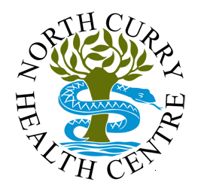

Welcome to
North Curry Health Centre

March 2026

INTRODUCTION

This booklet outlines the services we provide for our patients and will give you information that we hope you will find useful. Please read these notes carefully and keep them accessible for future reference. Our Practice has excellent facilities in pleasant surroundings and we aim to offer the population we serve a comprehensive medical service with an emphasis on continuity of care.

We moved into our purpose built, well equipped premises in 1981and the Practice has a list size of just over 4100 patients. We serve a wide area of approximately 85 Km^{2,} from Curland to Burrowbridge and Fivehead to Henlade. Please check on NHS England or on our website to make sure we cover your area.

http://www.northcurryhealthcentre.co.uk/new-patients.aspx

NEW PATIENTS

If you are living within our practice area you can register with us by completing forms provided by reception or printed from our website.
The practice area is as below – This map is also available on our website with zoom in and out facilities.

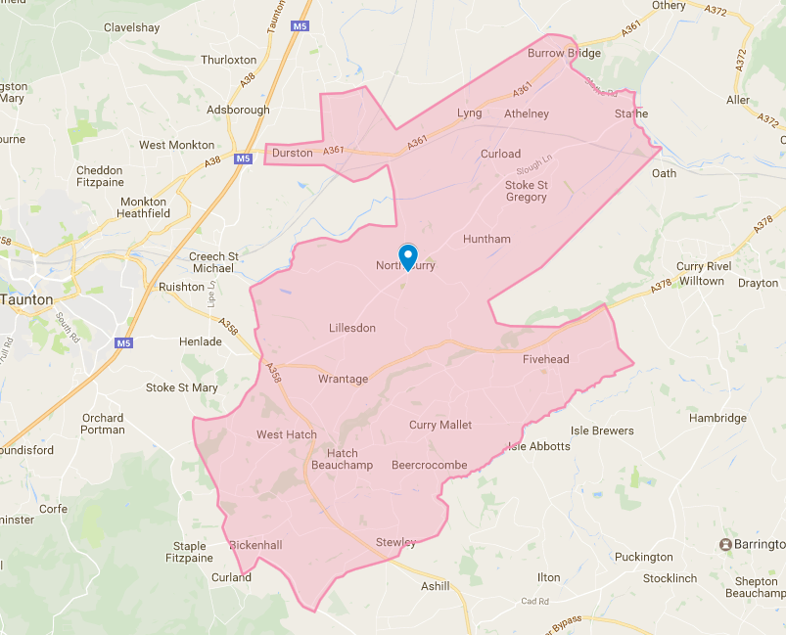

To register online go to: www.nhs.uk or search ‘Find a GP’.
This will take you to an online registration form. If you do not have access to the internet, please collect a form from reception to complete.

We may require some additional information, if we do, we will send you a text message / email. Please complete this and send back to us as soon as possible so we can get you registered with us.

TEXT APPOINTMENT REMINDER SERVICE

Please consent to receive text messages on your new patient questionnaire or patient details update form, (either download via our website or collect from reception).

Please let us know if you are unable to attend or no longer require your appointment so this can be offered to others

PATIENT REFERENCE GROUP (PRG)

We need the views and opinions of our registered patients. To join the PRG please ask reception for details. We will add your email address to a contact list. We will contact you via email every now and again to seek your views and opinions.
VIOLENCE POLICY

The NHS operates a zero-tolerance policy with regard to violence and abuse. The practice has the right to remove violent patients from the list with immediate effect to safeguard practice staff, patients, and other persons. Violence in this context includes actual or threatened physical violence or verbal abuse which leads to fear for a person’s safety. In this situation we will notify the patient in writing of their removal from the list and record in the patient’s medical records the fact of the removal and the circumstances leading to it.

CONFIDENTIALITY

Patient information is confidential, and all members of our team have a professional responsibility to take your confidentiality seriously. No member of our team will discuss your medical records without your consent. You have a right to keep your personal health information confidential between yourself and your doctor and to know who has access to your records.

STAFF TRAINING

We are closed from 13.00 – 16.30 on the last Thursday of every month for staff training.

NAMED GP

All patients are allocated to, Dr R Winter, Dr V Sutcliffe or Dr T Russell as their named GP. If you have a preference, please let the receptionist know and we will try to accommodate your request.

FACILITIES FOR THE DISABLED

Our patient facilities are located within ground floor level, with ramp and wide door access into the building and toilet facilities for patients with wheelchairs or walking aides. We also have a Hearing Loop in reception and a wheelchair available for any patient who has difficulty in walking.

TRAINING PRACTICE

We are an approved Training Practice for both doctors and paramedics seeking a career in General practice. GP Registrars are fully qualified doctors and are usually with us for a period of one year. We currently have paramedics on a rotational basis. Some consultations are recorded for training purposes, and we ask patients for their permission to take part.

E-MAIL ADDRESSES:

You are welcome to provide us with your e-mail address as a contact method. However please note that if others have access to your e-mails they may also see e-mails that we send to you, which may include confidential information

COMPLAINTS, COMPLIMENTS & SUGGESTIONS

We welcome you views and feedback, a Friends and Family form is situated in the waiting room. If you have any complaints these should be addressed to the practice manager in writing.

BOOKING APPOINTMENTS ON-LINE

This is accessed via the NHS App. Once you register for this service you will be able to book a selection of nursing appointments, order your medications, amongst other things.

Appointments can also be cancelled using this facility.

If you require a Chaperone, please let us know when booking the appointment or when checking in.

USEFUL TELEPHONE NUMBERS

Out of Hours | 111
District Nurses | 0300 323 0026
Musgrove Park Hospital | 01823 333444
Health Visitor | 0300 323 0115
Community Services for Adults | 0300 123 2244
Relate | 0300 772 9681
Samaritans | 01823 288998
SHARE  (Youth counseling & Information  Services) | 01823 277133

Please visit our website - www.northcurryhealthcentre.co.uk

APPOINTMENTS AND GENERAL ENQUIRIES (RECEPTION)

Telephone number: 01823 490505
Telephone lines: 08.00 – 18.30
Surgery open: 08.00 – 18.30
Phoning for results: Please call after 10.00am
Phoning for Home Visit: Please Try and Call before 11.30am
Please do not call reception for repeat prescription requests (see dispensary below)
Out of Hours: 111
Emergency: 999

Appointments

Routine Appointment: Where timescale is less important such as a medication review or review of a long term condition.

Acute Appointment: New problem or deterioration in an existing problem that really needs to be assessed and managed within 1-3 working days

Urgent Appointment: Something that really must be dealt with the same day because of its severity or risk to the patient.

Telephone consultations: If you feel a telephone call would suffice. These are at set times morning and afternoon.

Home Visits: Please call before 11:30 am. You may only request a home visit if you are housebound or are too ill to visit the practice.

To ensure you see the most appropriate person, in the correct appointment time frame the receptionist will ask you the nature of the problem or issue. The Doctors endorse this practice and guarantee this information will be treated confidentially.

Appointments are available Monday to Friday for both Doctors and Nurses.
Doctors’ surgery times
Morning surgery is from 09.00am – Midday
Evening surgery is from 15.30pm to 18.00pm.
Improved Access alternate Wednesday and Thursday18.30 – 19.00 (telephone appointments only)

Nurses’ surgery times
These vary daily.

Out of Hours
An Out of Hours medical service is available when the surgery is closed. This service is for medical emergencies only. If you become unwell after the surgery has closed, please telephone NHS 111.

DISPENSARY

Opening times: 09.00 – 13.00 14.00 - 18.30
Prescription line: 01823 490505 option 2 (11.00-13.00)

Any medication you need following a consultation will be dispensed at the time.

Ordering Repeat Medication (Online is the preferred method)

Online: Through the NHS App or via our website. NHS App is the preferred method for ordering repeat medication and allows access to repeat prescription requests 24 hours a day. Please allow 3 Full working days before collecting.

For more information please visit www.nhs.uk/apps-library/nhs-app/

Post: Either by the regular postal service or by patients dropping their requests into the ‘Repeat prescription letterbox’

By Telephone: Prescription Line on 01823 490505 (option 2) between the hours of 11.00 am - 13:00 pm. (As safety guidance discourages telephone ordering of prescriptions, this service is intended only for those patients who have no other means of ordering their prescriptions).

No medication requests can be taken via reception.

Repeat prescriptions can be dealt with only on the authority of a doctor and two full working days’ notice are required to process each request - please don't wait until you have run out.

SERVICES WE OFFER

Chronic Disease Management
The Practice Nurses run clinics for Diabetic, Respiratory (COPD & Asthma) and Heart disease.

Minor Operations
These clinics are held on an ad hoc basis.

Musculoskeletal Specialist
The practice has a MSK who holds a clinic on Tuesdays and Fridays.

Physiotherapy
Clinics are held fortnightly all day on a Wednesday. Referrals to this service are via your GP.

Cervical screening
Invitation letters are sent when your Cervical Smear is due.

Contraceptive services and Devices
These clinics are held on an ad hoc basis.

Midwife clinic
These are held off site.

Childhood Immunisations

Clinics are held fortnightly on a Tuesday afternoon. Invitation letters are sent by Child Health when vaccinations are due.

FLU and COVID VACCINATIONS

Covid clinics currently are in Spring and Autumn. Flu clinics are only in Autumn. Covid criteria changes from Spring to Autumn so please check if you are eligible on the Gov.uk website.

Attached Services

Community Nursing Staff are employed by the Primary Care Trust. They can be contacted directly on 0300 124 5606.
Health Visitors can be contacted on 0300 323 0115.

NON-NHS SERVICES

Travel
We do not offer private vaccines such as Rabies, Japanese Encephalitis or prescriptions for anti-malarial tablets. You will need to access these from a private travel clinic.

Reports, including those that require Medical Examinations
These are not provided under the NHS contract and a fee is charged. Please contact the practice secretaries for details.

THE PRACTICE TEAM

The PRACTICE MANAGER is Mrs. Sarah Keen. Sarah is responsible for administration and the running of the Practice. She is available during normal office hours Mon – Thurs to discuss any queries or complaints and is always happy to receive suggestions that may help to improve our service.

THE DOCTORS

Dr Rachel Winter (Partner)
MB BCH, DRCOG, MRCGP
Qualified Cardiff University 2010. GMC No: 7082094

Dr Vanessa Sutcliffe (Partner)
BMedSci, BM BS, DRCOG
Qualified Nottingham University 1998. GMC No: 4533584

Dr Thomas Russell (Partner)
MBBS, BSc, MRCGP, DMCC
Qualified University of London 2012. GMC No: 4533584

Dr Daryl Pearce (Associate GP)
MB, BS, DFFP, BDS, MRCGP, BSC
Qualified University College London 1991. GMS No: 3558025

Dr Emily White (Associate GP)
MBChB, DRCOG, MRCGP
Qualified University of Sheffield, 2015. GMC No: 7493058

Registrar
Dr Hana Musa

Paramedic
Oli Redstone

THE NURSING TEAM

Marinka Depledge Lead Practice Nurse
RGN Diabetic Nurse

Kelly Lorey Practice Nurse
RGN Respiratory Nurse

Hollie Wicks Healthcare Assistant

DISPENSARY

Joanne Ferrari (Senior Dispenser)
Joanne Badger
Karie Cresswell
Grace Kendall
Leila Evenden (Dispensary assistant)

RECEPTION

Charlene Hunsperger Kristina Hyatt
Louise Peters Mandy Saunders
Rose Parker Sam Perry

SECRETARIAL

Michelle Foulger Susan Parkman

ADMINISTRATIVE

Elaine White

RIGHTS & RESPONSIBILITIES

What patients can expect:

- To be treated with respect and politeness by all staff
- For confidentiality to be maintained at all times
- To be informed of any changes in service or alteration in practice
- To be informed of the complaints procedure
- To have a named accountable GP

What staff can expect:

- To be treated with respect by all patients. Please remember our staff are trying to help you.
- The doctors and nurses will determine the frequency of appointments for each patient as determined by the patient’s condition.
- Patients with routine problems will not use the Out of Hours service.
- To be informed if patients are unable to keep their appointments.
- Patients to be on time for appointments.
- Repeat medication request to be made in accordance with practice policy.

Help us to help you. Please inform us of any changes to your contact details as soon as possible.

NHS your Data Matters

To find out more information and select your preference go to the NHS UK website.

www.nhs.uk/your-nhs-data-matters/manage-your-choice

Greenway
North Curry
Taunton
Somerset
TA3 6NQ

01823 490505

reception.northcurryhc@nhs.net

www.northcurryhealthcentre.co.uk

